***MEMBER APPLICANT***

|  |  |  |
| --- | --- | --- |
|  |  |  |

*Last Name First Name Nickname for Name Badge*

|  |  |  |
| --- | --- | --- |
|  |  |  |

*Home Phone Cell Phone Email Address*

***SIGNIFICANT OTHER***

|  |  |  |
| --- | --- | --- |
|  |  |  |

*Last Name First Name Nickname for Name Badge*

|  |  |  |
| --- | --- | --- |
|  |  |  |

*Home Phone Cell Phone Email Address*

***BIRTHDAYS***

|  |  |
| --- | --- |
|  |  |

*Member’s Birthday Significant Other’s Birthday*

***ADDRESS***

|  |  |  |  |
| --- | --- | --- | --- |
|  |  |  |  |

*Street City State Abbreviation Zip Code*

***SIGNIFICANT CREW***

|  |  |  |  |  |
| --- | --- | --- | --- | --- |
| ***NAME*** |  |  |  |  |
| ***BIRTHDAY*** |  |  |  |  |

*1st Mate 2nd Mate 3rd Mate 4th Mate*

|  |
| --- |
| Check Number: |

***FINANCIAL ELECTIONS***

|  |  |  |
| --- | --- | --- |
| *Options* | *Price* | *Your Selections* |
| *Annual Dues:* | ***$200.00*** |  |
| *Dock Fee:* | ***$330.00*** |  |
| *Dry Sail Fee:* | ***$65.00*** |  |
| *Trailer Storage:* | ***$25.00*** |  |
| *Small Boat Rack:* | ***$20.00*** |  |
| *Winter Storage* | ***$100.00*** |  |
|  |  |  |
| *Total:* |  |  |

Make checks payable to: St. Marys Boat Club and send completed forms to:

St. Marys Boat Club

Brandi Dickey –Treasurer

3562 Pamona Drive

Beavercreek, Ohio 45440

All dues etc. and paperwork must be postmarked or in the hands of the Treasurer by February 1st to maintain your seniority for dock assignments.

**Commodore**

Phil Fuerst

**Vice Commodore**

Jim Benson

**Secretary**

Matt Dickey

**Treasurer**

Brandi Dickey

**Sail Fleet Captain**

Doug Drury

Membership Renewal

PLEASE PRINT

***MEMBER APPLICANT***

|  |  |
| --- | --- |
|  |  |

*Last Name First Name*

***BOAT INFORMATION***

|  |  |  |  |
| --- | --- | --- | --- |
|  |  |  |  |

*Boat Name Manufacturer Year of Manufacture State Registration Number*

|  |  |  |  |
| --- | --- | --- | --- |
|  |  |  |  |

*Length Beam Draft Sail Number or Hull Number*

**Commodore**

Phil Fuerst

**Vice Commodore**

Jim Benson

**Secretary**

Matt Dickey

**Treasurer**

Brandi Dickey

**Sail Fleet Captain**

Doug Drury

Dock Selection Form

PLEASE PRINT

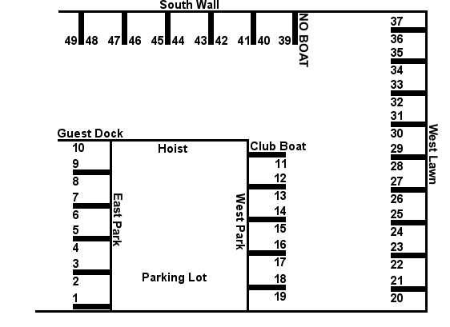

From this chart, please indicate your dock preference in rank order 1 through 10 with #1 being your first choice, #2 your second choice and so on through #10. The Dock Master reserves the right to assign boats to docks based on size and depth limitations. Boats larger than a Catalina 22 will only fit in certain docks. Every effort will be made to assign docks by member preferences based on seniority.

All dues etc. and paperwork must be postmarked or in the hands of the Treasurer by February 1st to maintain your seniority for dock assignments.

**Indicate Your Choices**

|  |  |  |  |  |  |  |  |  |  |
| --- | --- | --- | --- | --- | --- | --- | --- | --- | --- |
|  |  |  |  |  |  |  |  |  |  |

1 2 3 4 5 6 7 8 9 10

Would you like to have the same dock you had last year? ____ Yes ____ No

I would like to change my slip for the following reason(s): ________________________________________________________________________________________________________________________________________________________________________________________________________________________________________________